**ECA14 – Embedded System**

**List of Experiments**

| **S. No** | **Name of the Experiment** | **Remarks** |
| --- | --- | --- |
| **1** | Study Of Proteus micro Vision |  |
| **2** | Blinking Of Led Using 8051 Microcontroller Using Proteus |  |
| **3** | Generation Of Square Wave Using Proteus |  |
| **4** | Fade In Fade Out Of Led Using 8051 Using Proteus |  |
| **5** | Stepper Motor Using 8051 Using Proteus |  |
| **6** | Interfacing Of Relay Using 8051 Using Proteus |  |
| **7** | Led Toggle Using 8051 Using Proteus |  |
| **8** | 7 Segment Display Using 8051 Using Proteus |  |
| **9** | Led Chaser Using 8051 Using Proteus |  |
| **10** | Study of ARM Processor |  |
| **11** | Write and execute C program to blink LEDs using software delay routine in LPC2148 kit |  |
| **12** | Write and execute C program to read the switch and display in the LEDs using LPC2148 kit |  |
| **13** | Write and execute C program to display a number in seven segment LED in LPC2148 kit |  |
| **14** | Write and execute C program for serial transmission and reception using on-chip UART in LPC2148 kit. |  |
| **15** | Write and execute C program for accessing an internal ADC and display the binary output in LEDS in LPC2148 kit. |  |

Experiment no -01

**Study of Proteus and Keil Micro Vision**

**Aim:** To study the working procedures of Proteus and Keil Micro vision softwares.

**Keil Micro Vision** is a free software which solves many of the main points for an embedded program developer. This software is an integrated development environment (IDE), which integrated a text editor to write programs, a compiler and it will convert your source code to hex files too. μVision4 introduces a flexible window management system, enabling us to drag and drop individual windows anywhere on the visual surface including support for Multiple Monitors.

**KEIL PROCEDURE:**

1. Open the software, Click on project and open new version project.

2. Create a new project file

3. Enter AT89C51

4. Click NO

5. Click [Ctrl +N] and Type the code

6. Open project and click Build target

7. Open Build target and open source file and ADD, CLOSE

8. Click build target

9. Next debug start and stop

10. Open peripherals and select port 2

11. Now run the program in Debug

12. Open project and click optional properties and in that give output as hex file.

13. Create hex file.

**PROTEUS PROCEDURE:**

* Open proteus by clicking run as administrator.
* Open new project and enter the file name.
* Click next, next, next and finish.
* Click P symbol and search keyword and place the required components
* Now connect the components as required
* Give input to AT89C51 as HEX file.
* Start the simulation process

Result: Thus the Proteus and Keil Micro vision softwares were studied.

Experiment 02

**BLINKING OF LED USING 8051 MICROCONTROLLER USING PROTEUS**

**AIM:**

To Write an assembly language program to LED blink using 8051

**SOFTWARES REQUIRED:**

* Proteus software

**PROGRAM**

ORG 0000H

UP: SETB P2.0

ACALL DELAY

CLR P2.0

ACALL DELAY

SJMP UP

DELAY: MOV R4,#35

H1:MOV R3,#255

H2:DJNZ R3,H2

DJNZ R4,H1

RET

END

**CIRCUIT DIAGRAM:**

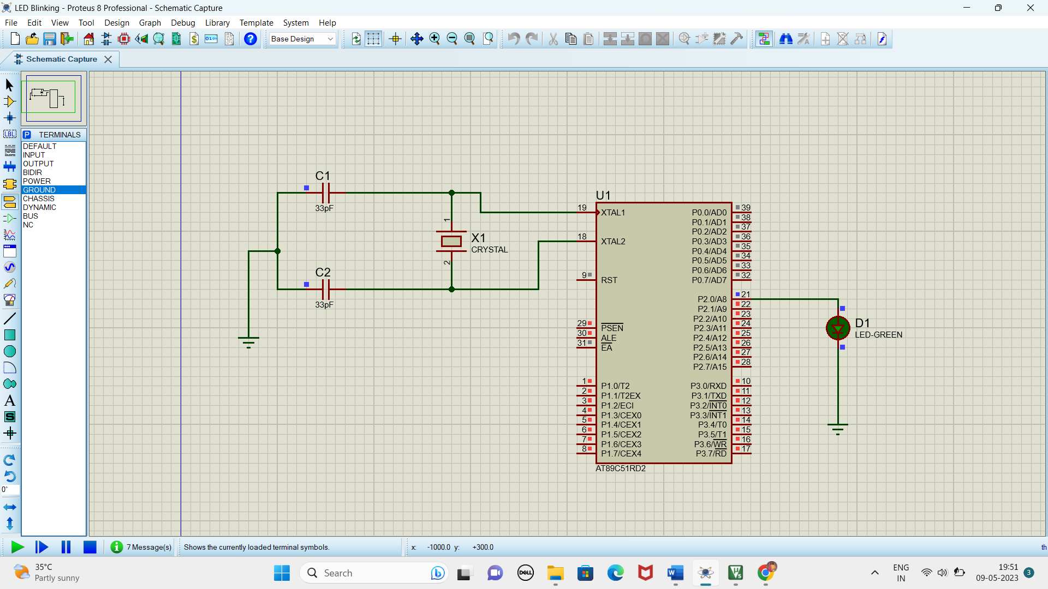

**RESULT**

Thus the program has been successfully verified and executed.

Experiment 3

**GENERATION OF SQUARE WAVE USING PROTEUS**

**AIM:**

Write an assembly language program to Generate square wave using 8051.

**SOFTWARE REQUIRED:**

* Proteus 8 software.

**PROGRAM**

ORG 0000H

UP: SETB P2.0

ACALL DELAY

CLR P2.0

ACALL DELAY

SJMP UP

DELAY: MOV R4,#35

H1:MOV R3,#255

H2:DJNZ R3,H2

DJNZ R4,H1

RET

END

**CIRCUIT DIAGRAM:**

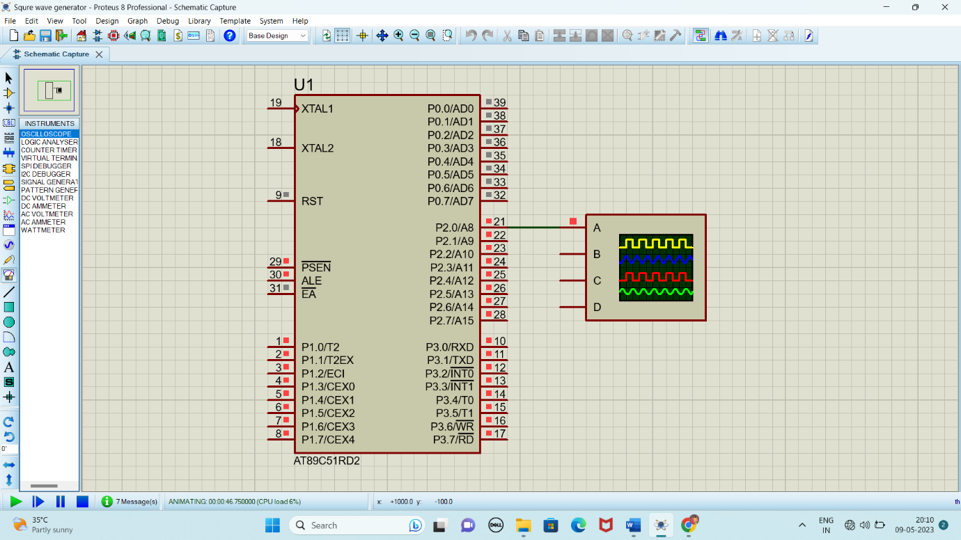

**OUTPUT:**

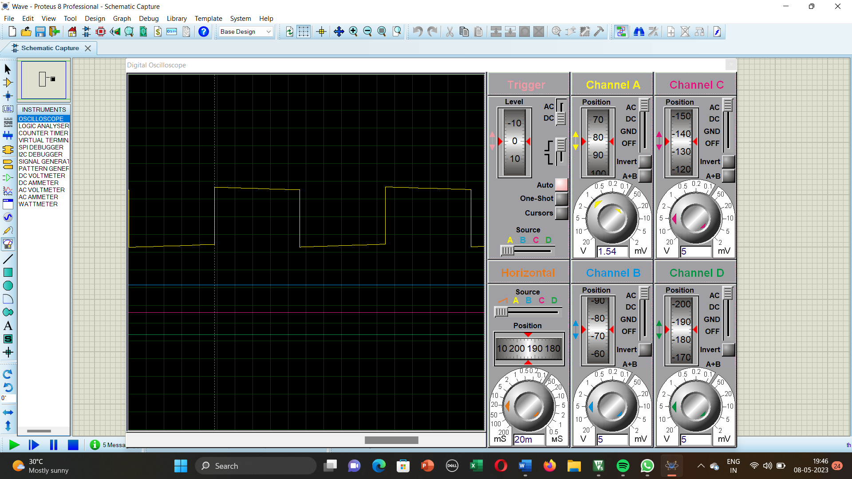

**RESULT:**

Thus the program has been successfully verified and executed.

Experiment 4

**FADE IN FADE OUT OF LED USING 8051 USING PROTEUS**

**AIM:**

Write an assembly language program for Fade in Fade out of LED Using 8051 using Keil and Proteus

**SOFTWARE REQUIRED:**

* Proteus 8 software.

**PROGRAM:**

#include <REGX52.h>

delay(unsigned int y)

{

unsigned int i,j;

for(i=0;i<y;i++)

{

for(j=0;j<1275;j++){}

}

}

main()

{

while(1)

{

delay(100);

P1_0 = 0;

delay(100);

P1_0 = 1;

}

}

**CIRCUIT DIAGRAM:**

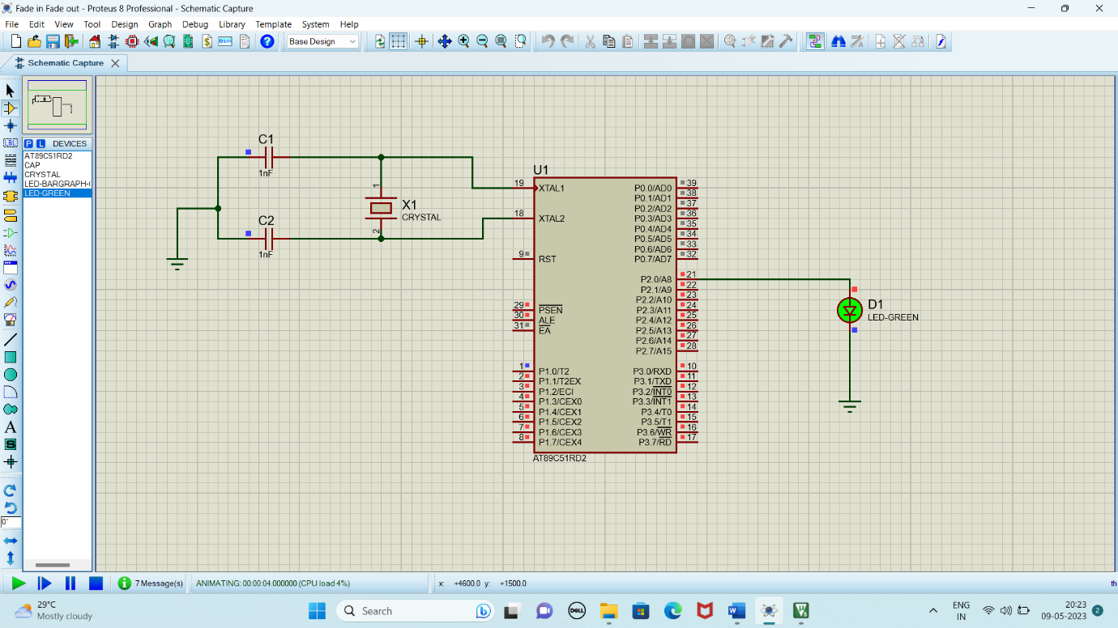

**RESULT:**

Thus the program has been successfully verified and executed.

Experiment 5

**STEPPER MOTOR USING 8051 USING PROTEUS**

**AIM:**

Write an assembly language program for Stepper Motor Using 8051 using Keil and Proteus

**SOFTWARE REQUIRED:**

* Proteus 8 software.

**PROGRAM:**

ORG 0000H

UP: MOV P2,#09H

ACALL DELAY

MOV P2,#0CH

ACALL DELAY

MOV P2,#06H

ACALL DELAY

MOV P2,#03H

ACALL DELAY

SJMP UP

DELAY:MOV R4,#18

H1:MOV R3,#255

H2:DJNZ R3,H2

DJNZ R4,H1

RET

END

**Circuit Diagram:**

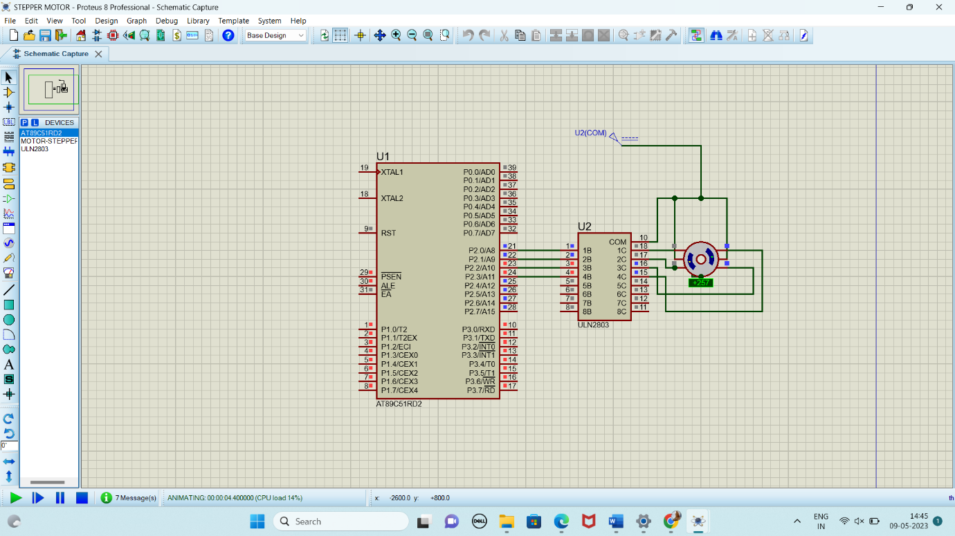

**RESULT:**

Thus the program has been successfully verified and executed.

Experiment 6

**INTERFACING OF RELAY USING 8051 USING PROTEUS**

**AIM:**

Write an assembly language program for Interfacing of Relay Using 8051 using Keil and Proteus

**SOFTWARE REQUIRED:**

* Proteus 8 software.

**PROGRAM:**

ORG 0000H

UP:SETB P2.0

ACALL DELAY

CLR P2.0

ACALL DELAY

SJMP UP

DELAY:MOV R4,#18

H1:MOV R3,#255

H2:DJNZ R3,H2

DJNZ R4,H1

RET

END

**CIRCUIT DIAGRAM:**

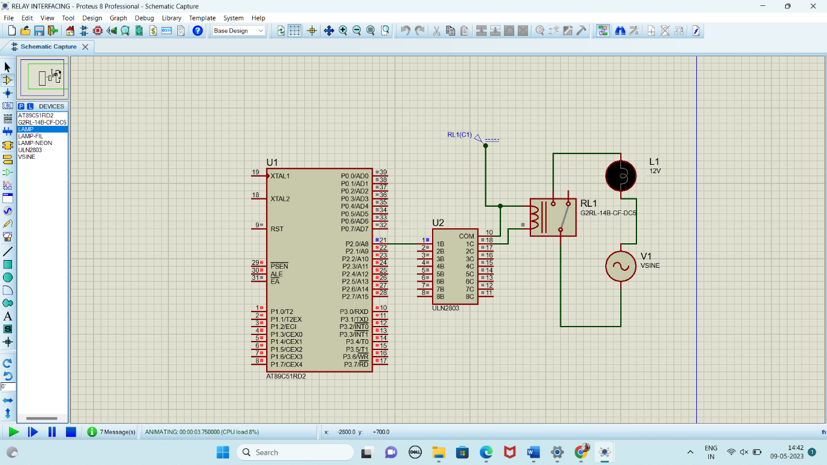

**RESULT:**

Thus the program has been successfully verified and executed.

Experiment 7

**LED TOGGLE USING 8051 USING PROTEUS**

**AIM:**

Write an assembly language program for LED Toggle Using 8051 using Keil and Proteus

**SOFTWARE REQUIRED:**

* Proteus 8 software.

**PROGRAM:**

ORG 0000H

UP: MOV P2,#55H

ACALL DELAY

MOV P2,#0AAH

ACALL DELAY

SJMP UP

DELAY:MOV R4,#10

H1:MOV R3,#255

H2:DJNZ R3,H2

DJNZ R4,H1

RET

END

**CIRCUIT DIAGRAM:**

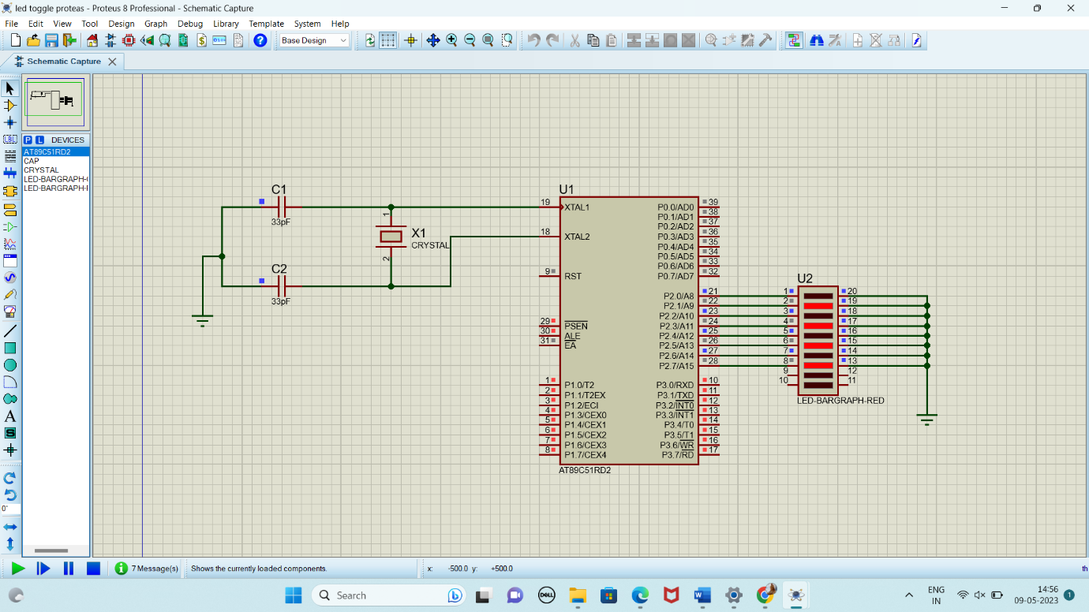

**RESULT:**

Thus the program has been successfully verified and executed.

Experiment 8

**7 SEGMENT DISPLAY USING 8051 USING PROTEUS**

**AIM:**

Write an assembly language program for 7 Segment Display Using 8051 using Keil and Proteus

**SOFTWARE REQUIRED:**

* Proteus 8 software.

**PROGRAM:**

ORG 000H

UP:MOV P2,#0C0H

ACALL DELAY

MOV P2,#0F9H

ACALL DELAY

MOV P2,#0A4H

ACALL DELAY

MOV P2,#0B0H

ACALL DELAY

MOV P2,#99H

ACALL DELAY

MOV P2,#92H

ACALL DELAY

MOV P2,#82H

ACALL DELAY

MOV P2,#0F8H

ACALL DELAY

MOV P2, #80H

ACALL DELAY

MOV P2,#90H

ACALL DELAY

DELAY: MOV R5,#10

H1:MOV R4,#180

H2:MOV R3,#255

H3:DJNZ R3,H3

DJNZ R4,H2

DJNZ R5,H1

RET

END

**CIRCUIT DIAGRAM:**

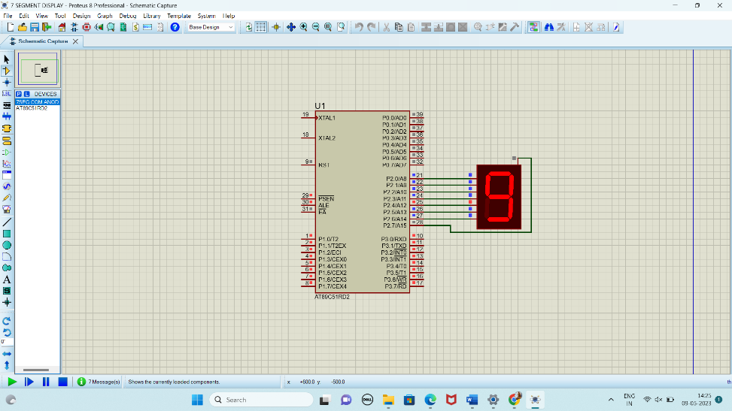

**RESULT:**

Thus the program has been successfully verified and executed.

Experiment 9

**LED CHASER USING 8051 USING PROTEUS**

**AIM:**

Write an assembly language program for LED Chaser Using 8051 using Keil and Proteus

**SOFTWARE REQUIRED:**

* Proteus 8 software.

**PROGRAM:**

ORG 0000H

UP: MOV P2,#01H

ACALL DELAY

MOV P2,#02H

ACALL DELAY

MOV P2,#04H

ACALL DELAY

MOV P2,#08H

ACALL DELAY

MOV P2,#10H

ACALL DELAY

MOV P2,#20H

ACALL DELAY

MOV P2,#40H

ACALL DELAY

MOV P2,#80H

ACALL DELAY

SJMP UP

DELAY: MOV R4,#255

H1: DJNZ R4,H1

RET

END

**CIRCUIT DIAGRAM:**

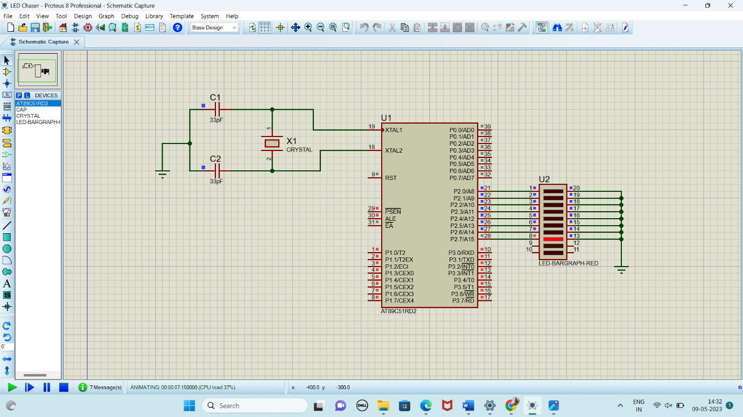

**RESULT:**

Thus the program has been successfully verified and executed.